**Create a Nested Virtualization Supported Hyper V on Azure**

* Once the Windows Machine once the VM is up and HyperV is installed, we need to setup a NAT-network
* Launch Powershell as Admin and Executed the following command New-VMSwitch -Name "InternalNAT" -SwitchType Internal  
  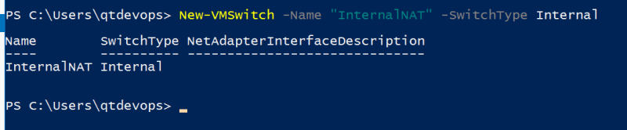
* View the Properties of the Switch and note the ifindex Get-NetAdapter  
  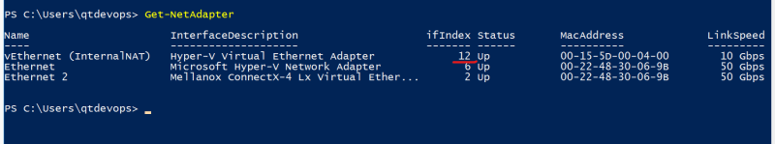
* Create an IP Address for NAT Gateway using belwo command New-NetIpAddress -IPAddress 192.168.0.1 -PrefixLength 24 -InterfaceIndex 12  
  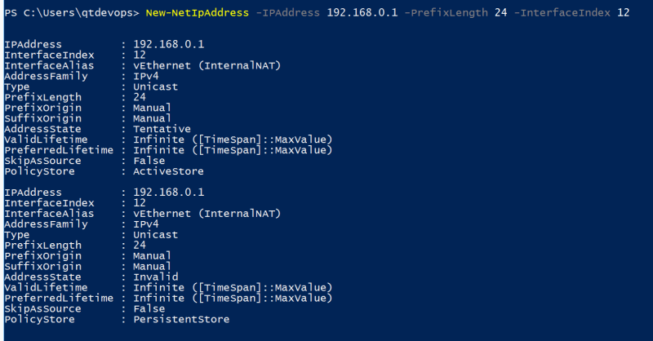
* Create a NAT Network New-NetNAT -Name "InternalNat" -InternalIPInterfaceAddressPrefix 192.168.0.0/24  
  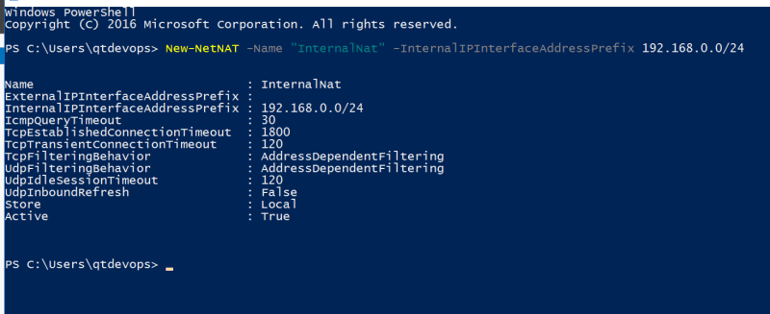
* Now to dynamically assign IP Addresses to the VMs which we are going to create inside the Hyper-V, we would be create a DHCP Server and Scope
* To Install DHCP Server, Add Roles and Feature => DHCP, Default installation steps (Continue Wizard next till the end of the wizard)  
  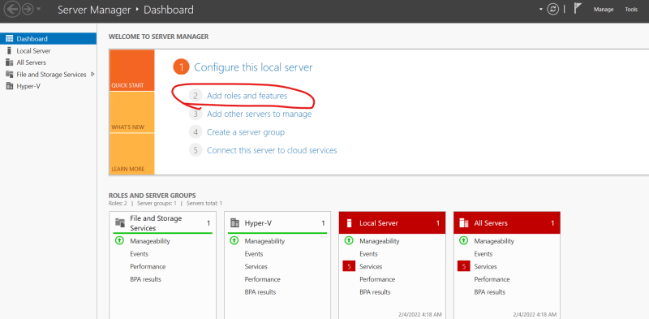  
  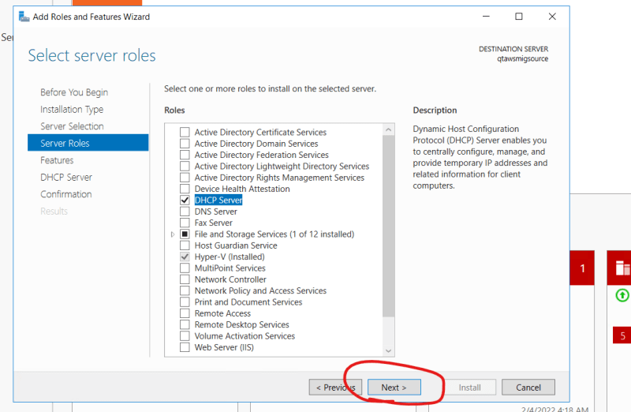  
  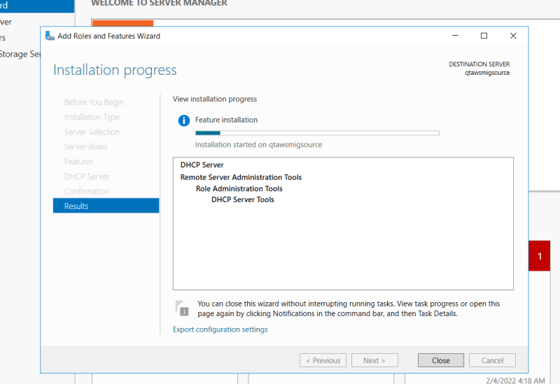  
  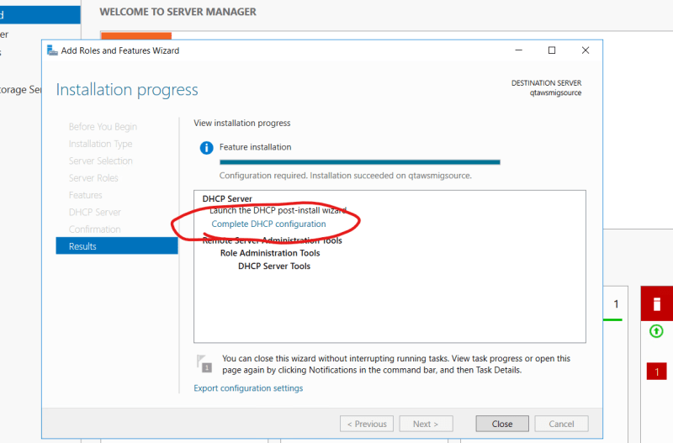  
  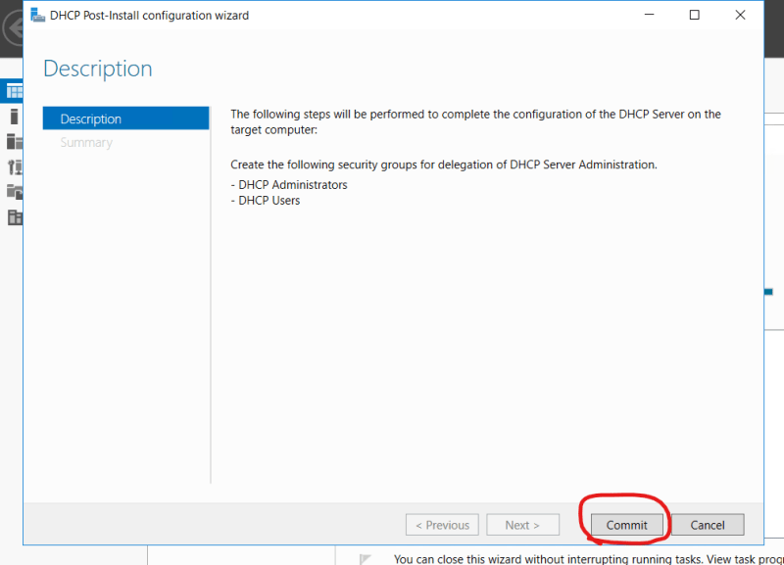
* Now Create DHCP Scope for IPV4  
  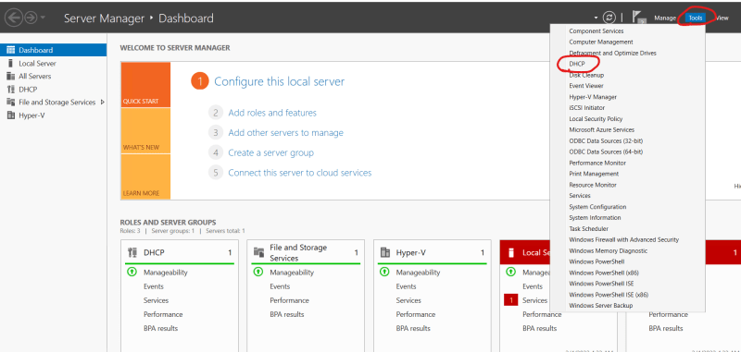  
  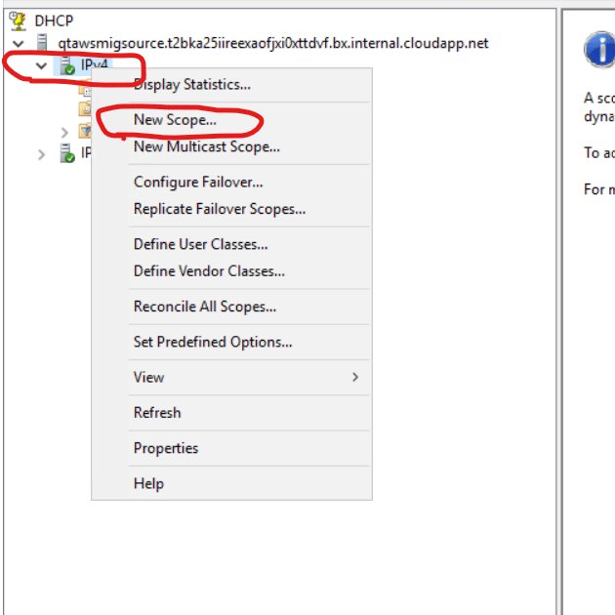  
  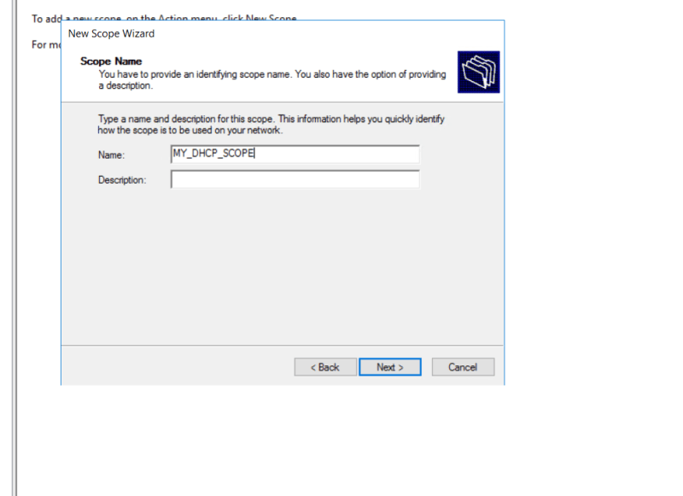  
  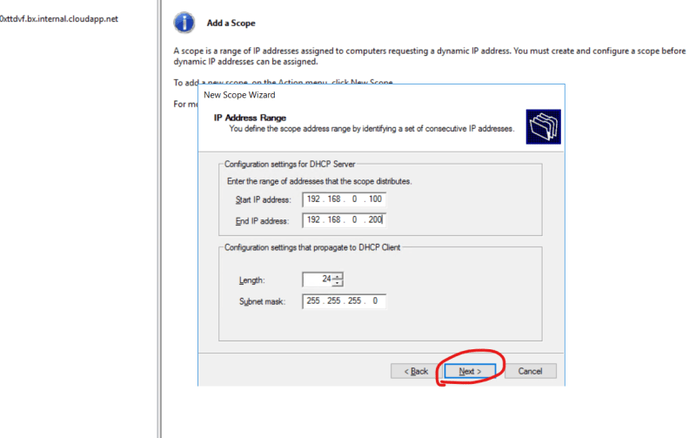  
  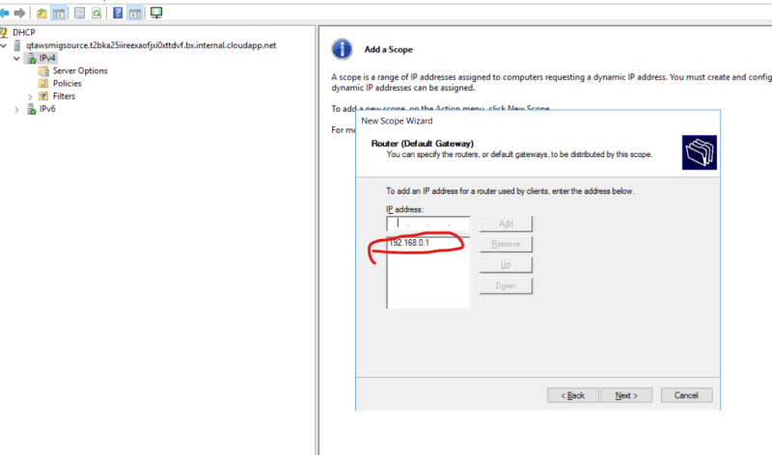
* Continue the rest of the stps till the close (end)

**Other Lab Setup**

* Lets install chocolatey on the Windows, Run Powershell as admin and install chocolatey by copying Set-ExecutionPolicy Bypass -Scope Process -Force; [System.Net.ServicePointManager]::SecurityProtocol = [System.Net.ServicePointManager]::SecurityProtocol -bor 3072; iex ((New-Object System.Net.WebClient).DownloadString('https://community.chocolatey.org/install.ps1')) or [Refer Here](https://chocolatey.org/install)
* Lets install Google Chrome using chocolatey

choco install googlechrome -y

* Lets install vagrant to create virtual machines choco install vagrant
* Now Restart the machine to create virtual machines
* To be continued in next session